Existing Holdings
0.3%  Weighted AMC^{[1]} | 17.68  10 Year Volatility^{[3]} | 9  Very Adventurous^{[4]}

[1] Annual management charge – the annual fee charge by the fund management company to cover costs directly associated with managing your fund. This will not include all costs associated with the fund.
[3]Portfolio future volatility is calculated as the standard deviation of the portfolio's simulated future values over a 10 year term using the portfolio's asset allocation. Simulated future values are based on stochastic simulations carried out with return, volatility and correlation projections for the underlying asset classes from Hymans Robertson.
[4] As a Very Adventurous investor you do not see yourself as a cautious person and usually view risk as a source of opportunity rather than as a threat. If you have substantial experience of investments and find financial matters easy to understand then you may be suited to a Very Adventurous approach to investing. You may also be suited to this approach if you make investment decisions quite quickly and are not generally anxious about those decisions. As a Very Adventurous investor you normally look for higher returns rather than safer investments and understand that you need to take considerable risk to meet your investment goals.
Investment | Provider | % Invested
NEST Higher Risk Fund Pension (GBP) | Nest Pensions | 100.00

Asset allocation

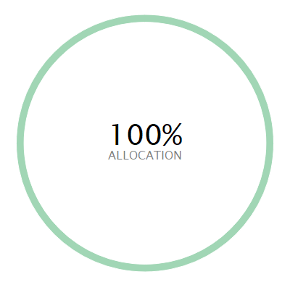 | ASSET ALLOCATION NET %⁽¹⁾ SHORT % LONG %  l Other 100.0 0.00 100.0
⁽¹⁾ Due to rounding there may be a discrepancy between the Long/Short % and the Net %.

Investment performance
Individual cumulative investment performance graph
The chart shows an investment’s performance, calculated as NAV to NAV/Bid to Bid/Closing Price to Closing Price, with dividends/distributions reinvested, including the effect of ongoing costs and charges. These figures are calculated to the performance date 19 March 2026.
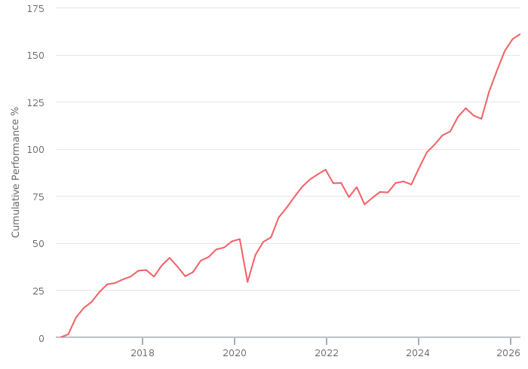
━━ | NEST Higher Risk Fund Pension (GBP)

Individual cumulative investment performance table
The table shows an investment’s performance, calculated as NAV to NAV/Bid to Bid/Closing Price to Closing Price, with dividends/distributions reinvested, including the effect of ongoing costs and charges.
FUND | Last Performance Update | 3M | 6M | 1YR | 3YR | 5YR | 10YR
NEST Higher Risk Fund Pension (GBP) | 28/02/2026 | 4.42 | 11.18 | 19.72 | 51.11 | 59.28 | 169.27

Individual discrete investment performance table
The table shows an investments performance, calculated as NAV to NAV/Bid to Bid/Closing Price to Closing Price, with dividends / distributions reinvested, including the effect of ongoing costs and charges. These figures are calculated for calendar years and / or the period within the current year specified.

Existing holdings individual discrete performance data
Fund | 2022 | 2023 | 2024 | 2025 | YTD
NEST Higher Risk Fund Pension | -10.2 | 12 | 13.83 | 16.44 | 4.12

